The elasticity of substitution between the inputs for F(L,K) = min (L,K) is deined to be sigma = 0.

Technological progress:

* More output with same input
* Labour saving: isoquant become faltter and sooner, if MRTS is lower (isoquant becomes flatter), any line from the origin through the isoquants

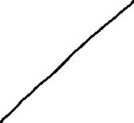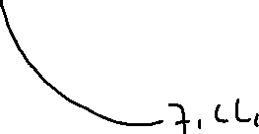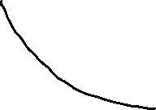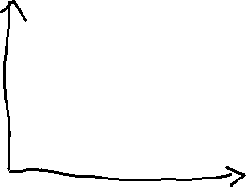

In the grapt above, f2 is flatter than f1 at the crosspoint

* Capital saving: MRTS is higher for any line feom origin through the isoquants
* Neutral isoquants does not change shape

f1(L,K) = L\*K^(1/2) for L>=1

MRTS1 = K/L MRTS2 = 1/(1/2)\*(K/L) = 2K/L

Since MRTS2 >=MRTS1, this is capital saving

Explicit cost: costs, outlays

Implicit costs: things forgone oppournity.

e.g. using saving to buy house, the actual cost is the price of the house, and the implicit cost (economc cost) is the forgone interest you’ll earn in the interest of the money.

e.g.2. should you start a firm?

- explicit costs: $100k salaries, $80k supplies

- implicit costs: $75k forgone wages

- oppournity cost = $180 explicit costs + $75k implicit costs = $255k in total

Oppournity costs are foreword-looking. => Often use resale market price to calculate oppoutnity cost



Cost minimization:

* Production quota f(L,K) = Q0



* Cost of a unit of labour is w
* Cost of a unit of capital is r

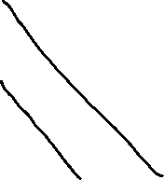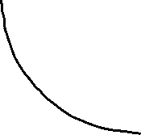

* Firms’s total cost = wL+rK

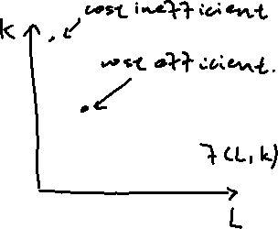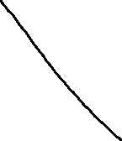

* Isoquant: set of L, K such that f(L,K) = Q0 for som Q0 >= 0



* Isocost: set of L, K wuh that wL+rK = C0, for some C0 >= 0



=> K = C0/r-wL/r

If the solution is interior and f is differentiable, then we get the

tangencey condition, MRTS(L,K) = w/r at the cost minimizing bundle

e.g. f(L,K) = 50(LK)^(1/2), w = 5, r = 20, Q0 = 1000

Tangency: (1/2)/(1/2)\*(K/L) = 1/4, K = L/4

Production: 50(LK)^(1/2) = 1000

K = L/4

So L = 40, K = 10

e.g. f(L,K) = 10L+ 2K, w = 5, r = 2, Q0 = 200



isoquant: 10L + 2K = 200,

K = 100-5L

Isocost: 5L + 2K = C0

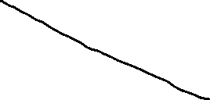

K = C0/2+5L/2

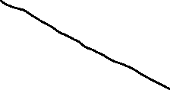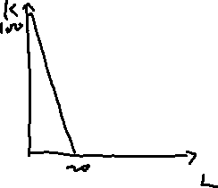

Cost minimization input: L = 20, K = 0

Check “bong for back”

MP/w = 10/5 = 2 > MP/r = 1

Comparative statics

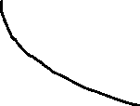

What happen whtn wage intercross from w1 to w2?

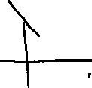

Using less labour and increase the tech

Price elastiicity of input demands

E(k,r) = %delta K/%delta r = (delta K)\*r/(delta r)\*K

E(L,w) = %delta L/%delta w = (delta L)\*w/(delta w)\*L

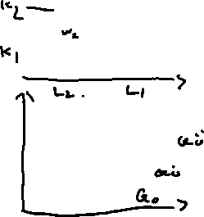

Changes in Q0: the crosspoints of expension path and Q0

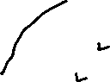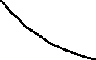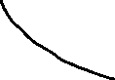

made up the engel curve

* A normal good will increase whtn Q0 increase,
* A inferior good otherwise

Short run: period of time or which at least one input is fixed (capital)

Cost: avoidable at shutdown => vary with output => variable, non-sunk cost

=> variable, sunkcost

=> not vary with output => non-variable, non-sunk cost

=> non-variable, sun cost

unvaoidable at shutdown => does not vary with output => sunk cost

e.g. f(L,K)= 50(LK)\*(1/2), fix capital at K bar, output Q0 => solve production constrain for L

500(LK)^(1/2) = Q0, L = Q0^2/2500/K

Total cost: wQ0^2/2500Kbar + rKbar